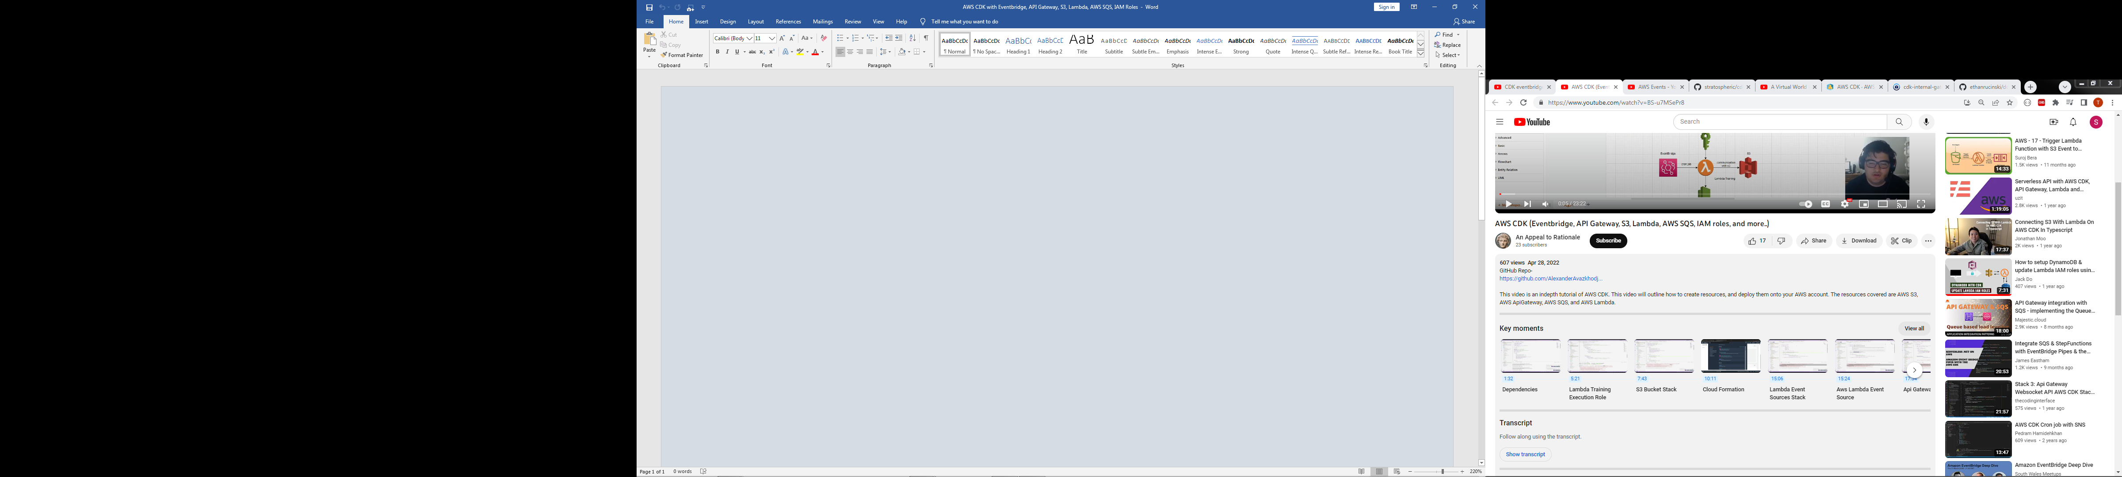

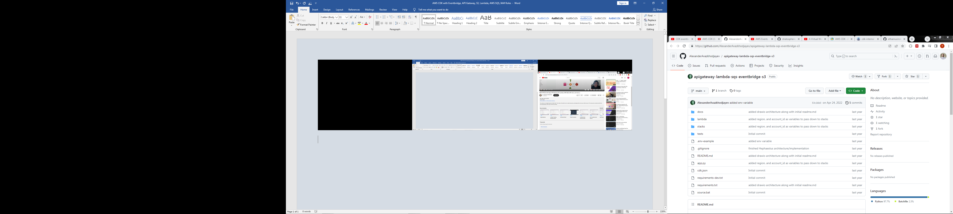

<https://github.com/AlexanderAvazkhodjayev/apigateway-lambda-sqs-eventbridge-s3>

